ADVANCE LAB ON JINJA :
🎯 Problem Statement
Imagine Flipkart has a production web server.
The DevOps team wants every production server to display a standard index.html page containing information about that particular server.
The page should automatically display:
- Environment: Production
- Number of CPUs → obtained automatically from Ansible Facts
- RAM → obtained automatically from Ansible Facts
- Administrator name → provided through an Ansible variables file
- Administrator email → provided through an Ansible variables file
The team does not want to manually edit the HTML file for every server.
Instead, they want Ansible to dynamically generate the webpage using a Jinja2 template.

Expected Web Page
When a user opens the website, they should see something like:
╔══════════════════════════════════════════╗
║ FLIPKART PRODUCTION ║
╠══════════════════════════════════════════╣
║ ║
║ Environment: Production ║
║ ║
║ This machine has: ║
║ CPU: 2 vCPU ║
║ RAM: 4 GB ║
║ ║
║ For any changes, contact: ║
║ Administrator: Akshat Gupta ║
║ Email: akshat@example.com ║
║ ║
╚══════════════════════════════════════════╝
The important part is that CPU and RAM can be different on every EC2 instance, while the administrator details come from a variables file.

variables.yml
|
| admin + email
↓
Ansible Playbook
↑
|
Ansible Facts
(CPU + RAM)
|
↓
Jinja Template
(index.html.j2)
|
↓
Generated index.html
|
↓
EC2 Web Server
###
On your Ansible EC2:
mkdir jinja-lab
cd jinja-lab
Create:
mkdir templates
Your project should look like:
jinja-lab/
│
├── variables.yml
├── deploy.yml
│
└── templates/

└── index.html.j2
Create the Variables File
This is important because we want students to understand that these values are not coming from the template.
Create:
nano variables.yml
Put:
---
admin: "Akshat Gupta"
email: "akshat@example.com"
environment: "Production"
Now we have:
admin → Akshat Gupta
email → akshat@example.com
environment → Production
These are Ansible variables.

Create the Jinja Template
Create:
nano templates/index.html.j2
<!DOCTYPE html>
<html>
<head>
<title>Flipkart Production Server</title>
</head>
<body>
<h1>Flipkart Production Environment</h1>
<h2>Server Information</h2>
<p>
Environment:
<strong>{{ environment }}</strong>
</p>
<p>
This machine has
<strong>{{ ansible_facts['processor_vcpus'] }} vCPU</strong>
and
<strong>{{ ansible_facts['memtotal_mb'] }} MB RAM</strong>.
</p>
<h2>Need Changes?</h2>
<p>
Please contact:
</p>
<p>
Administrator:
<strong>{{ admin }}</strong>
</p>
<p>
Email:
<strong>{{ email }}</strong>
</p>
</body>
</html>

🔥 Stop and Understand the Jinja
This one file contains two different sources of information.

Variables file
admin: "Akshat Gupta"
email: "akshat@example.com"
environment: "Production"
We use them as:
{{ admin }}
{{ email }}
{{ environment }}

Ansible Facts
The server itself tells Ansible:
CPU = 2
RAM = 3943 MB
We use:
{{ ansible_facts['processor_vcpus'] }}
and:
{{ ansible_facts['memtotal_mb'] }}

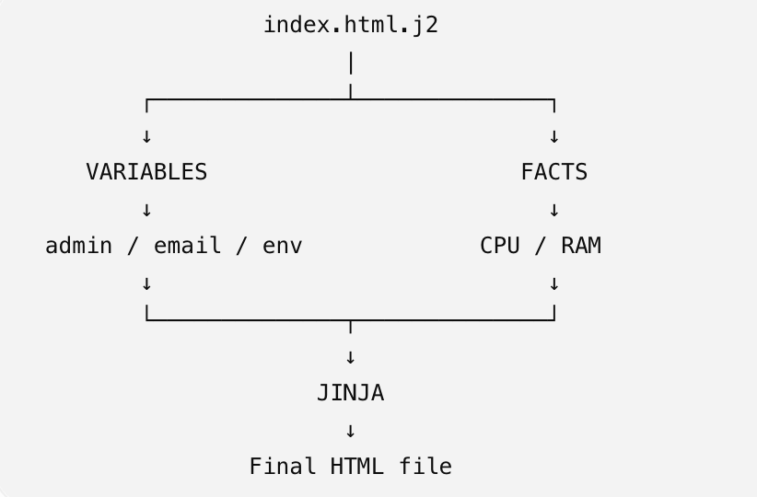
Create the Playbook
Create:
nano deploy.yml
Put:
---
- name: Deploy Production Server Page
hosts: webservers
become: true
vars_files:
- variables.yml
tasks:
- name: Install Nginx
apt:
name: nginx
state: present
update_cache: true
- name: Deploy dynamic index page
template:
src: templates/index.html.j2
dest: /var/www/html/index.html
mode: '0644'
- name: Start Nginx
service:
name: nginx
state: started
enabled: true
ansible-playbook -i inventory deploy.yml
Ansible will:
1. Connect to EC2 Node
↓
2. Gather Facts
↓
3. Discover CPU
↓
4. Discover RAM
↓
5. Read variables.yml
↓
6. Read index.html.j2
↓
7. Replace {{ }} values
↓
8. Create /var/www/html/index.html
↓
9. Start Nginx

